**Rep: Have changed All corrections. Please check and share your feedback**

**For Start Work Page**

After the user presses Done, the remarks page does not show up.

* After the user presses the Done Button, it should lead to the Remarks (Feedback) Page.

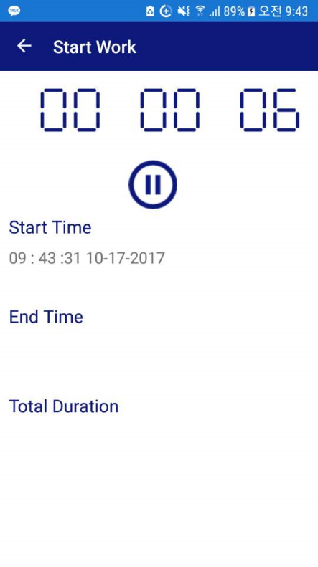**Start Work Page:**

So the user pressed the start button and it looks like this page.(so far no error)

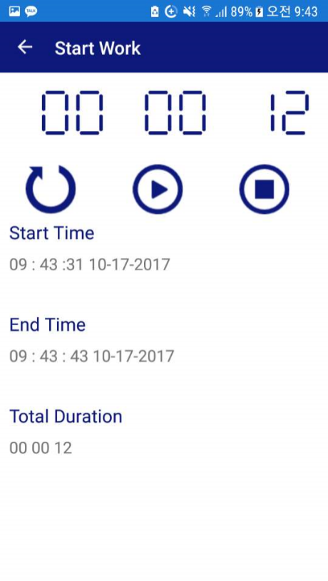

User presses the Pause Button and this page shows up. So far no error

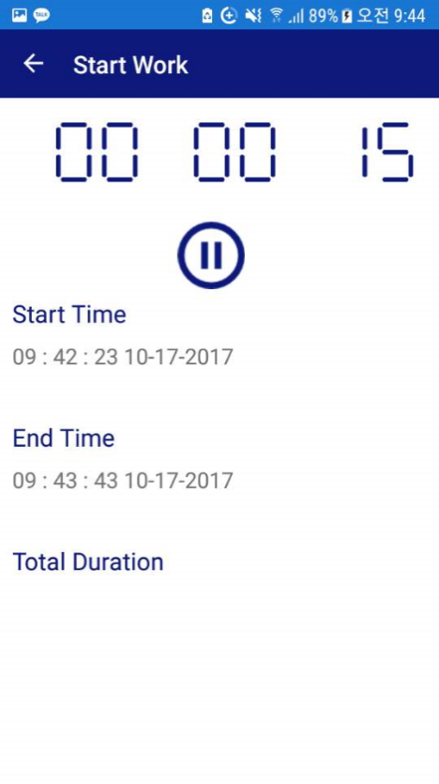

Then, user presses resume and the Start Time changes. It used to be 09:43:31, but then it changes to 09:42:23 (as displayed in the picture).

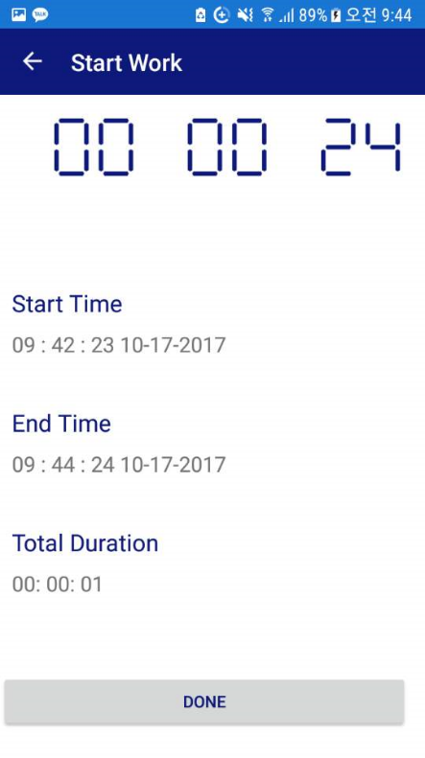

This Page, the user pressed the Stop button and the Finish Button. Here, there is an error in the Total Duration where it shows 00:00:01, when it should show the actual duration which is 00:00:24.

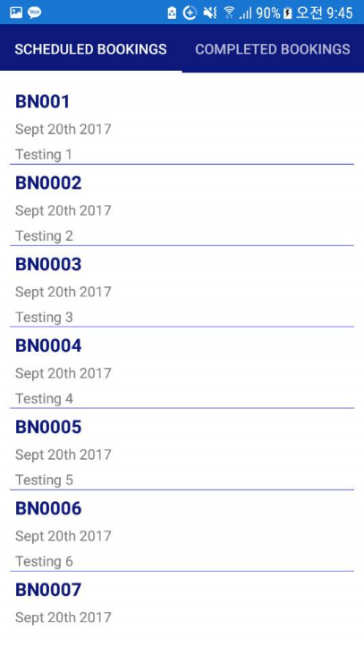

This is the page it leads to after pressing done from the Start Work page. There is no top menu and no hamburger button.

After pressing done, it does not even lead to the Remarks Page first.

User should be lead to the Remarks Page after pressing done in the Start Work Page, then after pressing the Submit Button at the Remarks Page It should lead to a Bookings page that has the top menu and the hamburger button on the top menu.

D

**For Contact Us Page**

User should not be able to edit it, only trace and copy.

Currently, the user is able to edit the contact us page. (the keyboard bar shows up and it should not show up)

Make it that the user can only trace and copy texts.

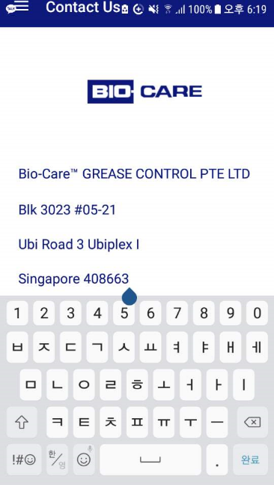

s